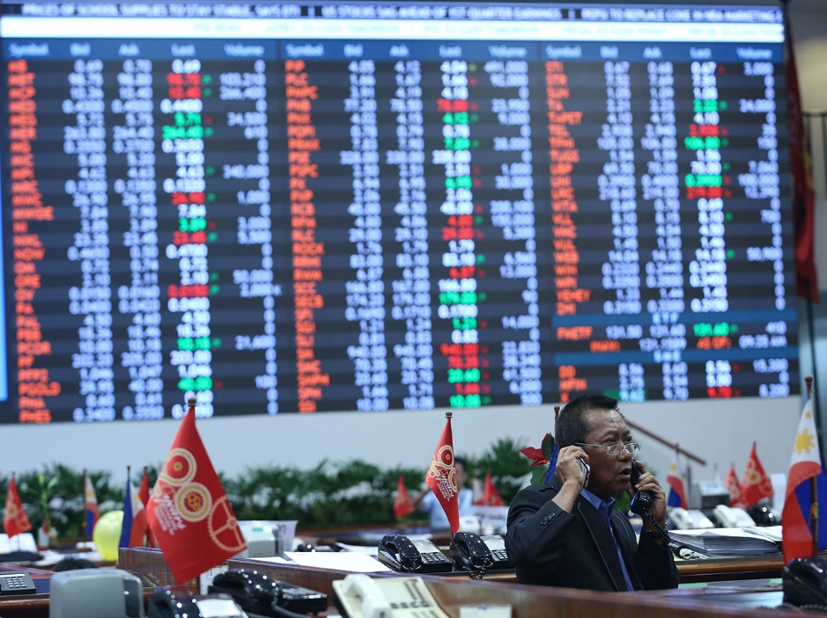MANILA, Philippines – The [Securities and Exchange Commission](http://www.rappler.com/business/151976-sec-approves-ppp-listing-rules) (SEC) on Wednesday, January 4, announced a new governance code for listed firms that aims to increase shareholder protection by increasing the responsibility of boards, especially when it comes to corporate reporting.

The code took effect last January 1, and all publicly listed firms are required to submit a new Manual on Corporate Governance to the SEC on or before May 31.

The full text of the new code can be viewed [here](http://www.sec.gov.ph/wp-content/uploads/2016/12/2016_memo_circular_no.19.pdf).

One key feature is the adoption of a "comply or explain" approach that combines voluntary compliance with mandatory disclosure.

Companies do not have to fully comply with the code, but they must state in their annual corporate governance reports whether they comply with the code provisions, identify any area of non-compliance, and explain the reasons for non-compliance.

"The new code is intended to raise the corporate governance standards of Philippine publicly listed corporations to a level on par with its regional and global counterparts," said SEC Chairperson Teresita Herbosa in a statement.

"The adoption of the 'comply or explain' approach is also expected to address the perceived overregulation of the SEC," she added.

Jointly crafted with the International Finance Corporation (IFC), a member of the World Bank Group, the new code also steers local listed companies toward practices that would ultimately attract more [foreign investment](http://www.rappler.com/business/156224-sc-affirms-sec-foreign-ownership-guidelines).

"Improved corporate governance will make Philippine companies more competitive and enhance their ability to attract foreign capital, leading to the development of a vibrant and sustainable private sector," said IFC Philippines country manager Jane Yuan Xu. **–**

http://www.rappler.com/business/157338-sec-ifc-revised-corporate-governance-code-listed-firms